**Main Menu:** 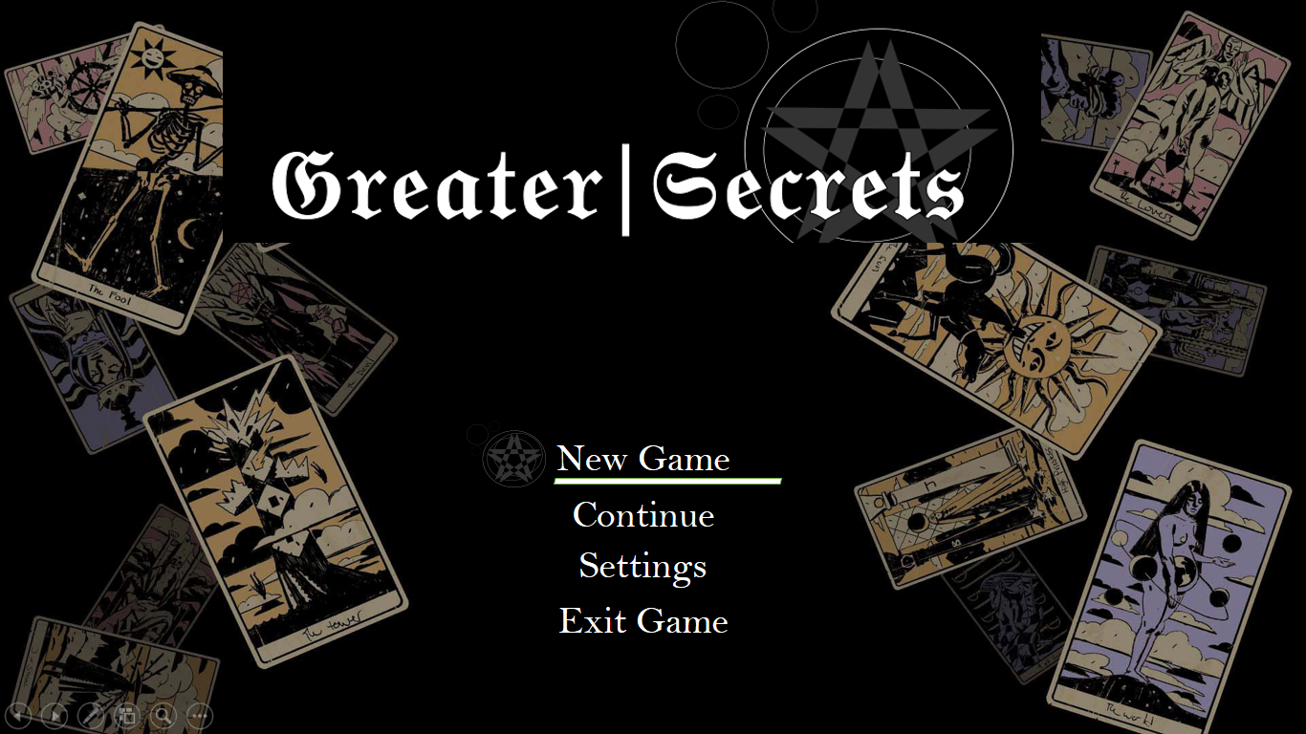

**Logo:**

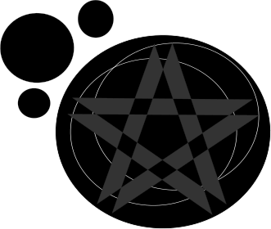

**Screenshots:**

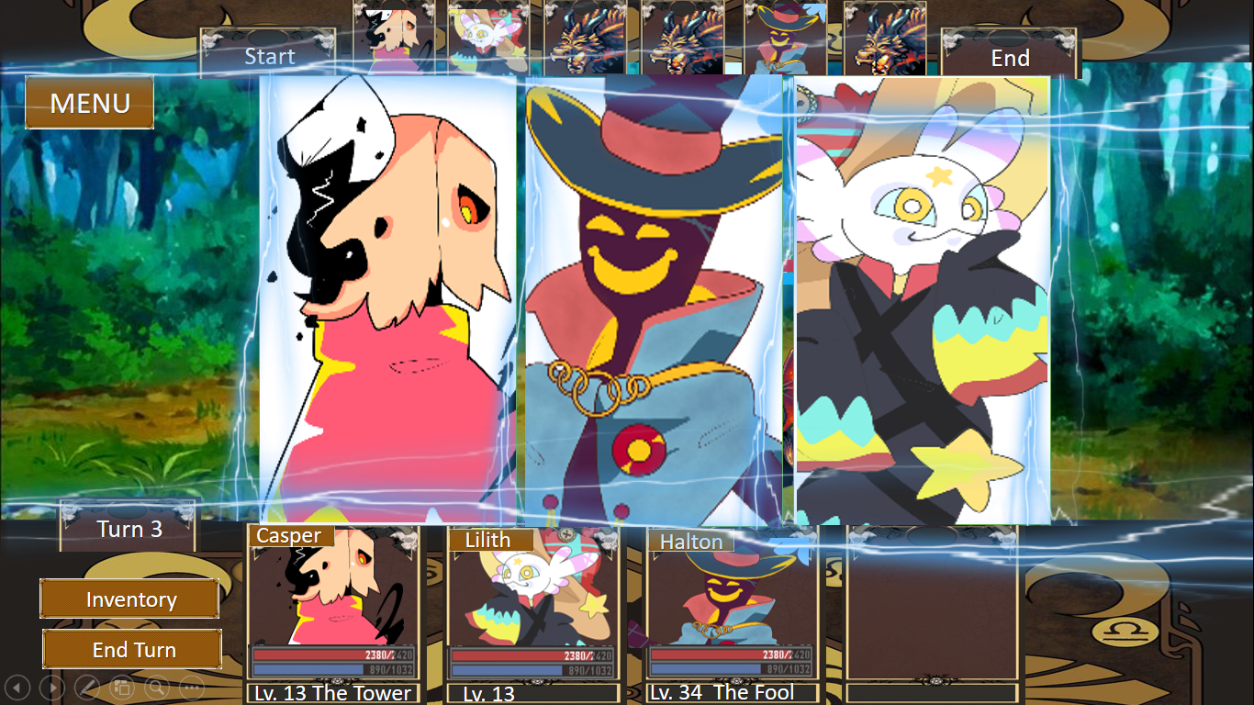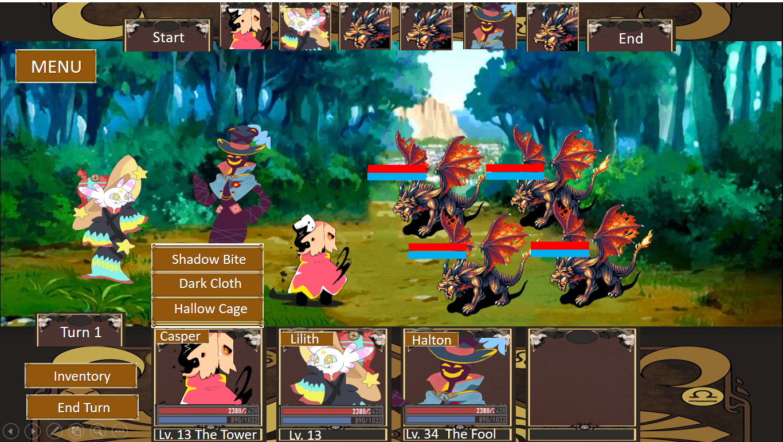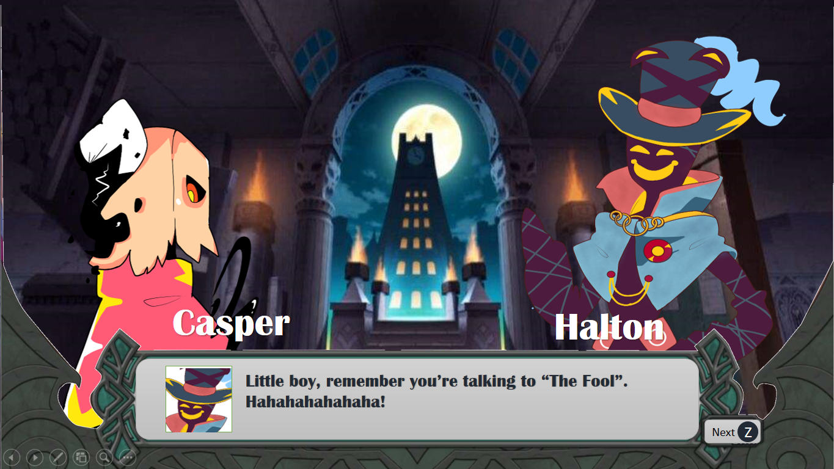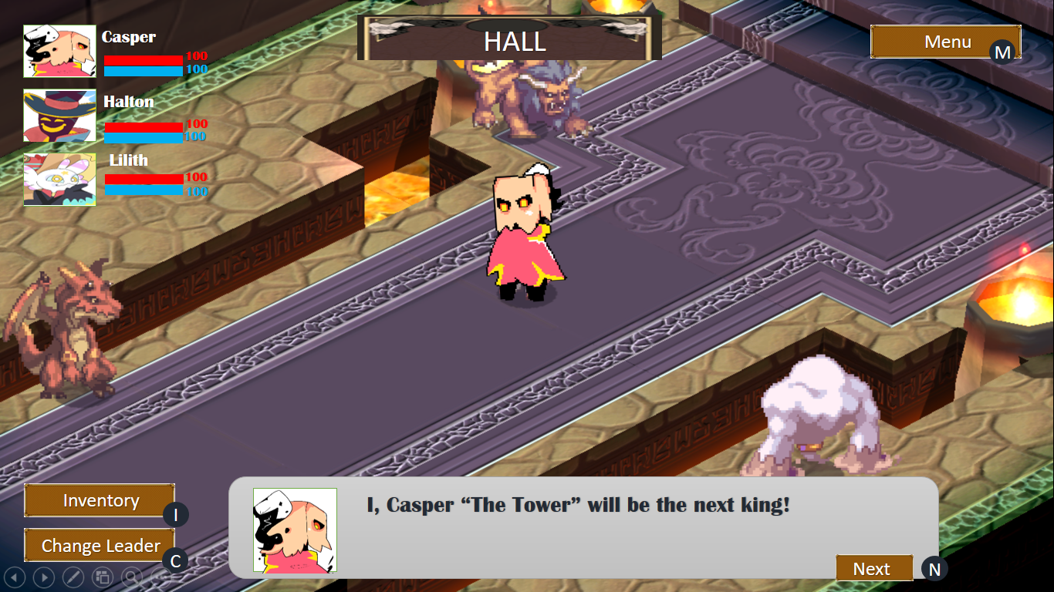

N

**Game title:** Greater Secrets

**Genre**: Turn-based RPG/strategy RPG, fantasy

**Player/Target Market:** General Audience

**Gameplay**: In this game you played or control the main character of the game, Casper. The game consists of different missions that undertakes in the counter lists. In the counter lists the player can manage their team members, select or equip items and other more functions. When the player is ready to go they can select a map and do the missions, in order to unlock other maps and missions the player need to finish the first map and its attached missions as well as replay any missions they have already completed. Each maps consists of chapters that is in order. Each time the player finished a map and all its chapters a cutscenes based on the story will appear. When the player is in the battle field the player can choose abilities in each player before the battle begins. In the battle field there is a start and end where the player can see which character will attack first and last. The player can create different combos or special attacks based on their character’s abilities type. Each characters can carry up to 10 items where it helps their stats stronger. When the player successfully completes a mission, they are given bonus items based on their overall bonus score, which is earned through combo attacks, special attacks, and other features of the game. The game can be played through multiple times, as each game features multiple endings. However, each time, the player's party, with all characters, items, and abilities, are counter lists.

**Story**: Casper (The Tower) is one of the Arcana Nights but considered as the weakest of them all, because of that no one in the Trionfi World respects him instead mock him and want to take or steal his position in the Arcana nights. In order to recognize by other Arcana nights and the people of the Trionfi World, he decided to join the “Greater Secrets” competition that held every 10 years with his own build team and win the title “The Major Arcana”.